MEDIA RELEASE
DATE
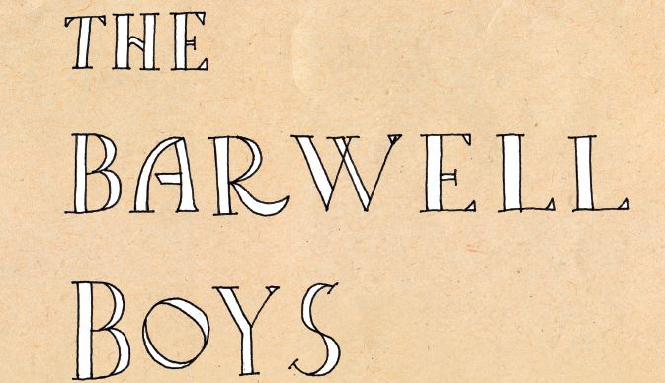

ORGANISATION NAME is pleased to present The Barwell Boys: South Australia’s British Farm Apprentices, a joint project of the History Trust of South Australia, the Barwell Boys and Little Brothers Family and Friends Association.
Early in the 20th century thousands of migrants came to Australia to seek a healthy and prosperous new life. Most of them were from the United Kingdom, in line with Australia’s “White Australia” policy of the time. In 1913 the South Australian Government started a youth migration scheme to help meet the state’s demand for agricultural labourers. British boys aged 14 and over were invited to become apprentices on SA’s farms.
Among the many migrants who came to South Australia seeking a new life in the early twentieth century were over 1,750 British boys who arrived under the Barwell and Little Brothers farm apprenticeship schemes. These boys and young men went to work on the land, and their varied experiences reflect the families and farms they were sent to and the work to which they were put.
The Barwell Boys: South Australia’s British Farm Apprentices display explores the history of the youth migration schemes, the experiences of the boys, and their contributions in later life.

Where XXXXXXXXXXXXXXXXXX
When XXXXXXXXXXXXXXXXXXX
For more information call XX XXXX XXXX

